|  |  |  |
| --- | --- | --- |
|  | **JSPM’s**  **RAJARSHI SHAHU COLLEGE OF ENGINEERING**  **TATHAWADE, PUNE-33**  **(An Autonomous Institute Affiliated to Savitribai Phule Pune University, Pune)** |  |

1. **Statement of Clear Goal, Use of appropriate methods, Significance of results, Effective presentation**

**Name of the Course:** Machine Learning

**Name of the Faculty:** Dr. Dipmala Salunke

**Name of the Innovative Method used:** Google Colab

**Name of the topic:** SVM Classifier

**Statement of Clear Goal:** To enhance students' understanding of SVM classification by leveraging Google Colab for interactive hands-on practice, enabling real-time experimentation, visualization, and exploration of algorithms to solidify conceptual clarity.

**Significance of result:**

After using Google Colab for the SVM classification topic, students gained practical knowledge of implementing SVM algorithms, visualizing decision boundaries, and fine-tuning hyperparameters. They demonstrated:

1. **Improved Concept Retention:** Students could better relate theoretical concepts with practical applications.
2. **Enhanced Problem-Solving Skills:** Students were able to solve SVM-related problems more confidently.
3. **Increased Engagement:** The interactive environment of Google Colab fostered greater participation in lab sessions.

**Effective Presentation (Screenshot):**

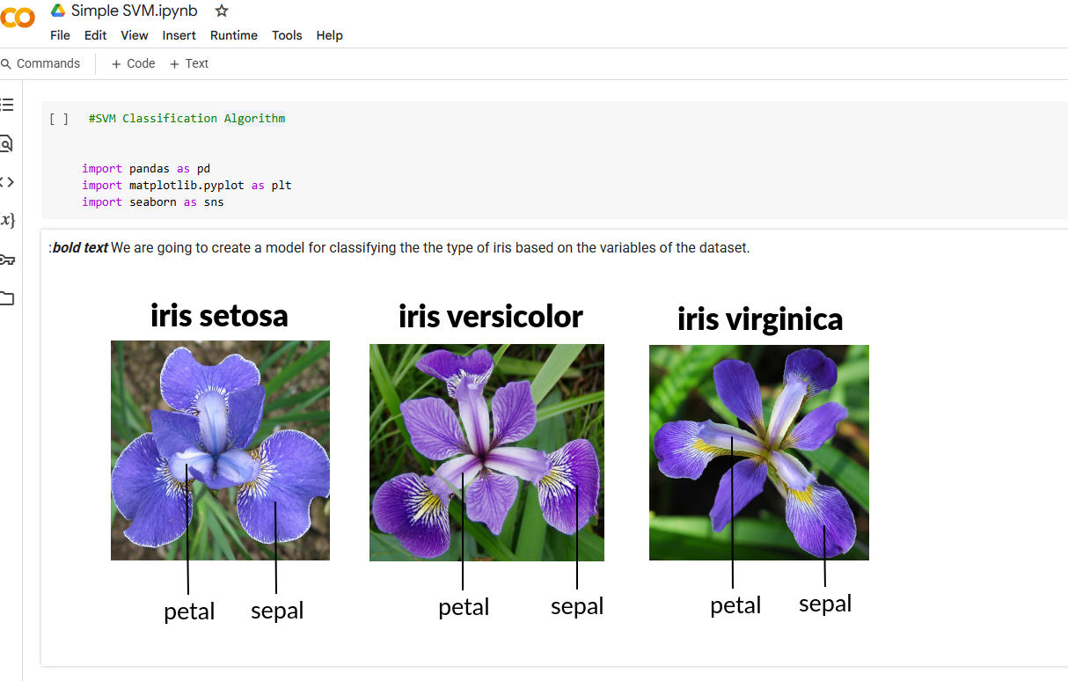

1. **Availability of work related to Innovation by Faculty in Teaching and Learning is on Institute website.**

[**https://www.jspmrscoe.edu.in/information-technology/innovation-practices**](https://www.jspmrscoe.edu.in/information-technology/innovation-practices)

**C. Availability of work for peer review and critique.**

[**https://github.com/jspmIt/Dipmala-Salunke**](https://github.com/jspmIt/Dipmala-Salunke)



